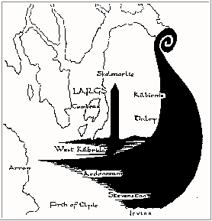 | North Ayrshire Family History Society  MEMBERSHIP APPLICATION FORM
Please print this form and complete it by hand and mail it, along with your subscription, for the attention the Membership Secretary at the address given below.
Mr. / Mrs. / Miss / Ms (Delete as appropriate)
Forename(s) ___________________________________________________________
Surname ______________________________________________________________
Email_________________________________________________________________
Address ____________________________________________________________
___________________________________________________________________
Post / ZIP Code ________________________
I / We wish to apply for (please tick as appropriate)
Ordinary Membership (within the UK) ------------ £14.00
Family Membership (anywhere) ------------------- £18.00
Ordinary Membership (outwith the UK) ---------- £18.00
Total Amount Enclosed -------- £__________
Overseas member are requested, where possible, to pay in Sterling.
Cheques should be made payable to North Ayrshire Family History Society.
Data Protection Act UK (1998) The Society maintains lists of members' name, addresses and subscription details for administration and research purposes only. These will not be given, lent or sold to any third party. Information supplied on this form may be published in the Society's Journal. If you object please tick here.
Signature _____________________________ Date (DD/MM/YY) _________________
To :- The Membership Secretary
North Ayrshire F.H.S.
c/o 1 Spalding Drive
Largs
Ayrshire
Scotland
KA30 9BZ

